**Git hub notes**

Git hub Repository:

Step 1: Sign in to your git hub account

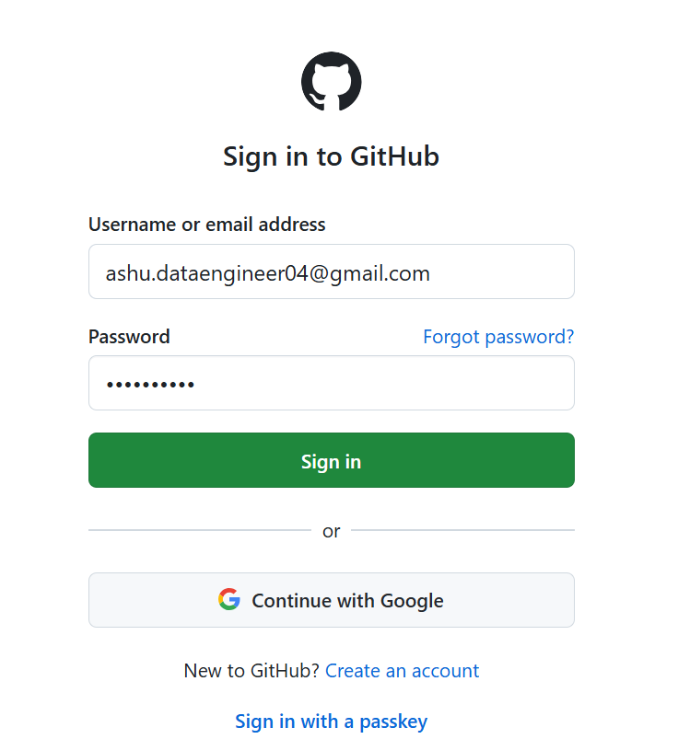

Step 2: Create new repository

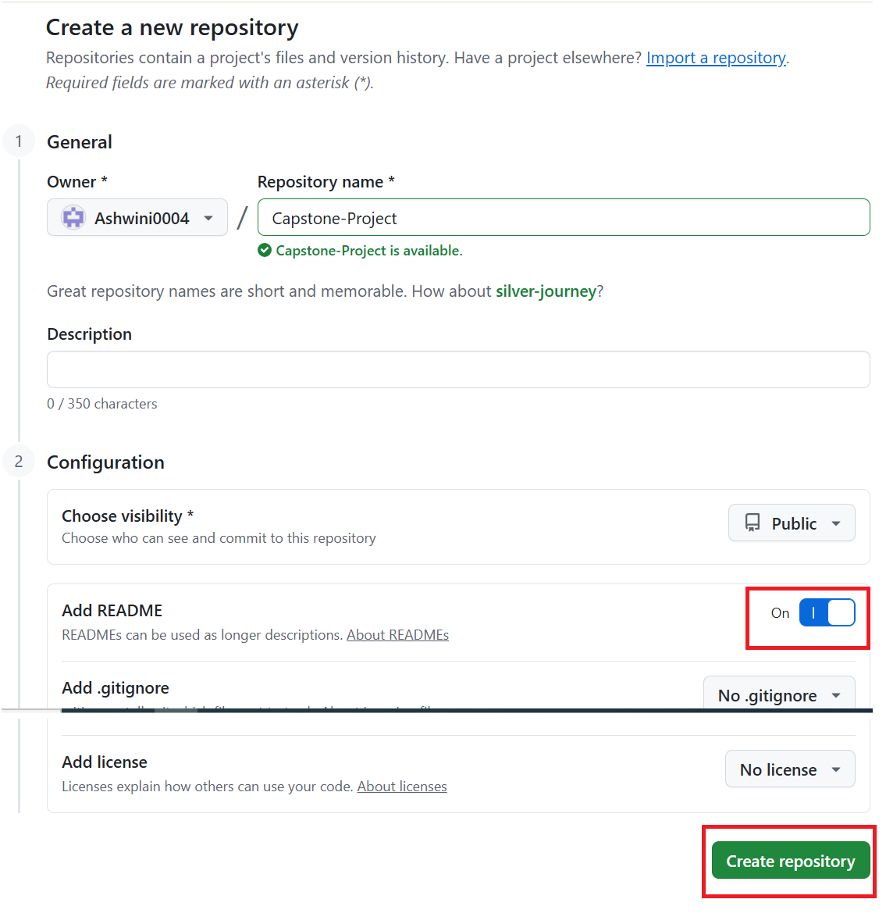

Step 3: Copy Git hub URL

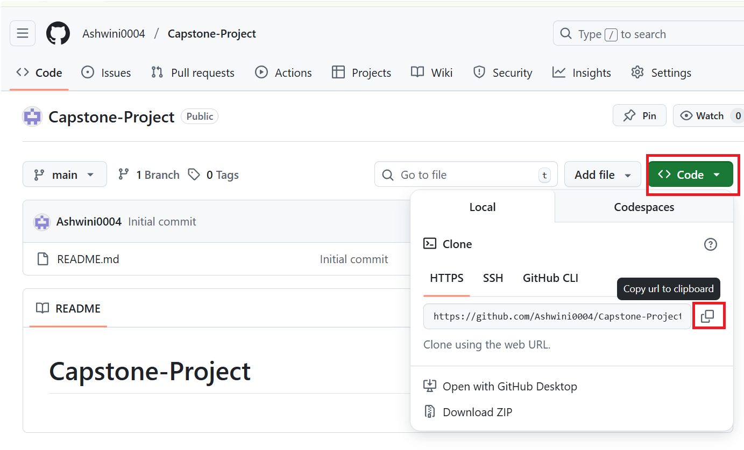

Step 4: Create Git folder in our databricks account

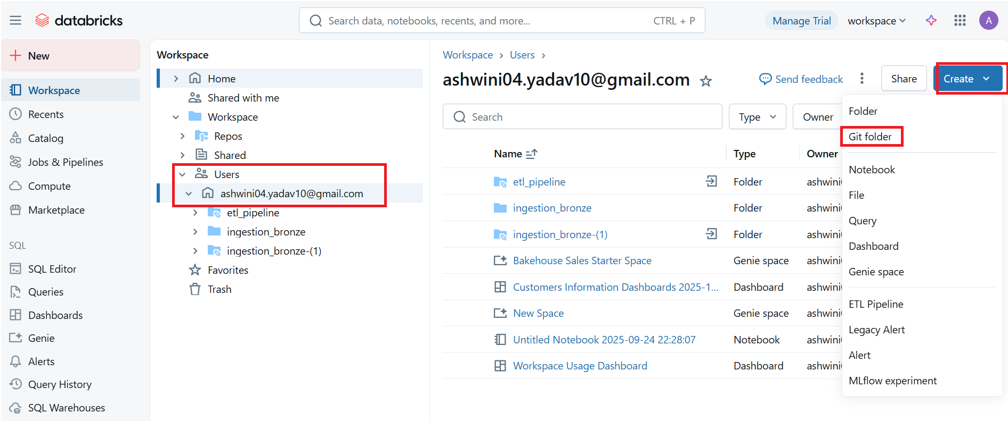

Step 4: Paste it git hub URL into our databricks

It is simply just git hub into our databricks and our databricks into our git hub account.

But still, we haven’t created connection in between. So, need step 5.

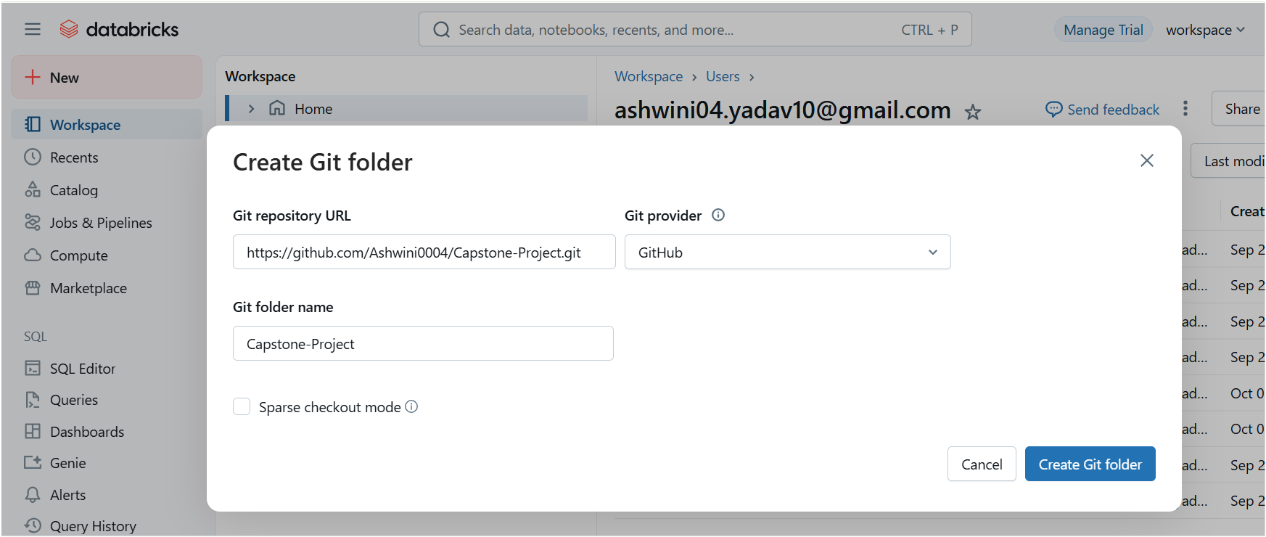

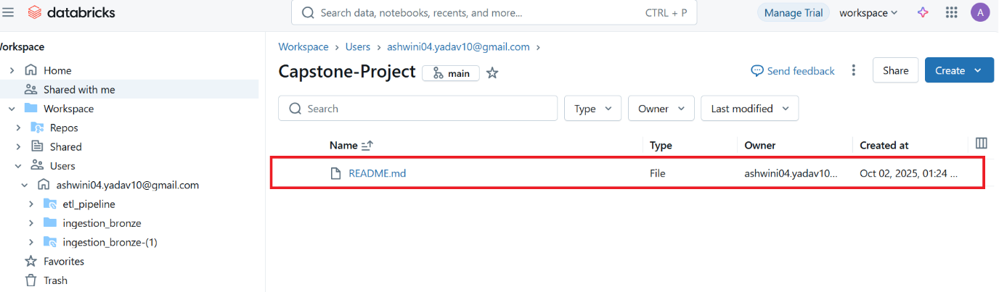

Step 5:

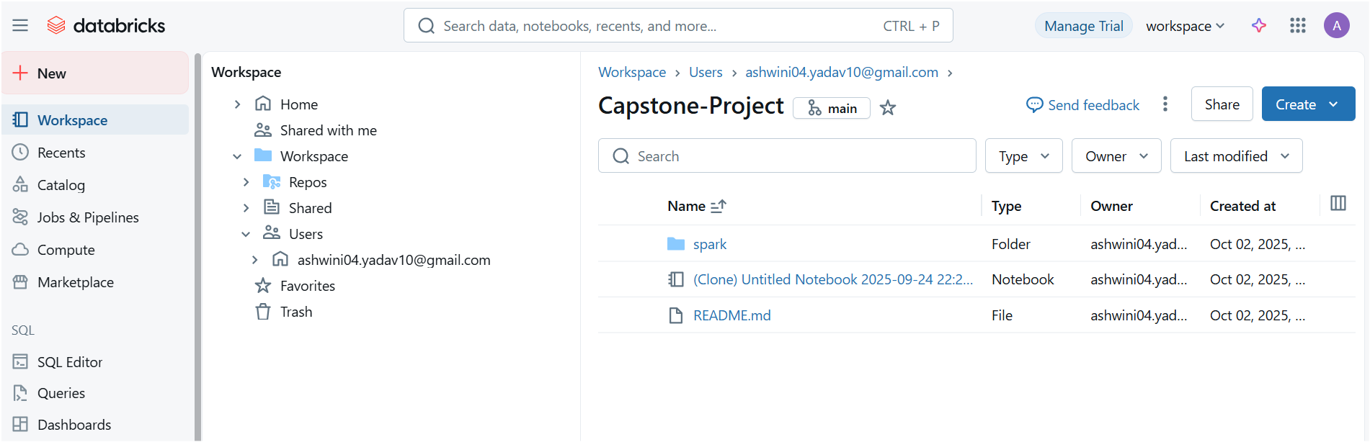

Here we create one folder, inside folder one notebook, one notebook in our git folder inside databricks. It still not seen in our git hub account, cos still we not configure it to the git hub.

Step 6: Configure databricks to git hub

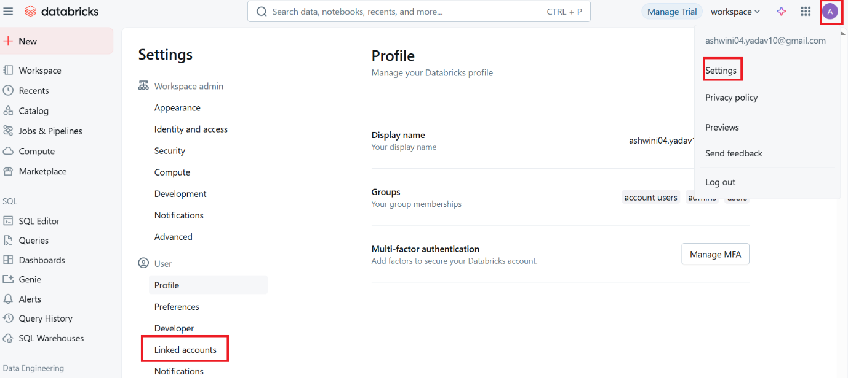

If we are not configuring following error will come.

Goto 🡪 our databricks git hub folder notebook 🡪 click on main 🡪 try to commit

It will give an error. Need to configure.

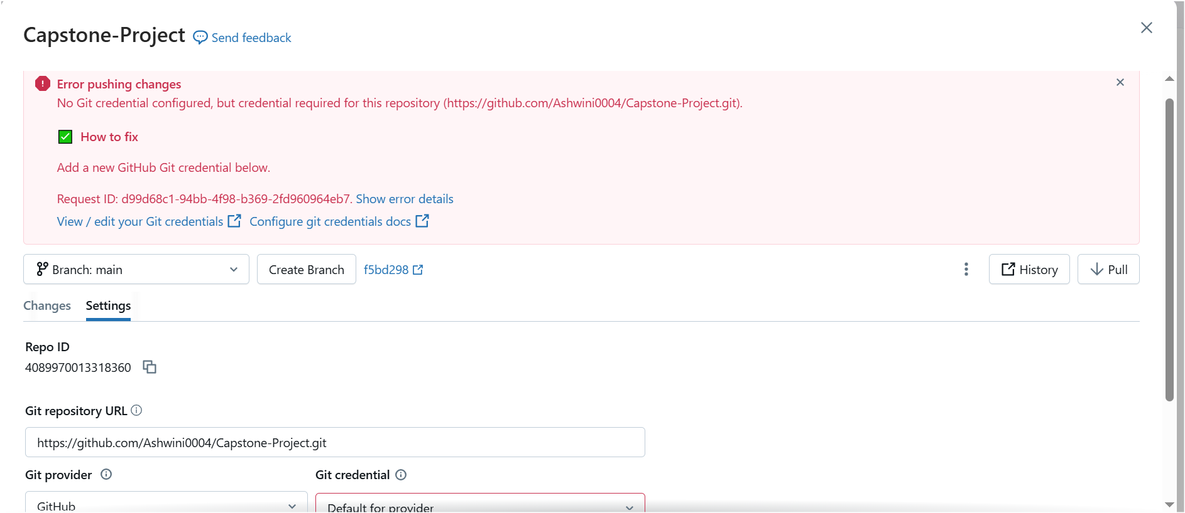

Step 7: Configure

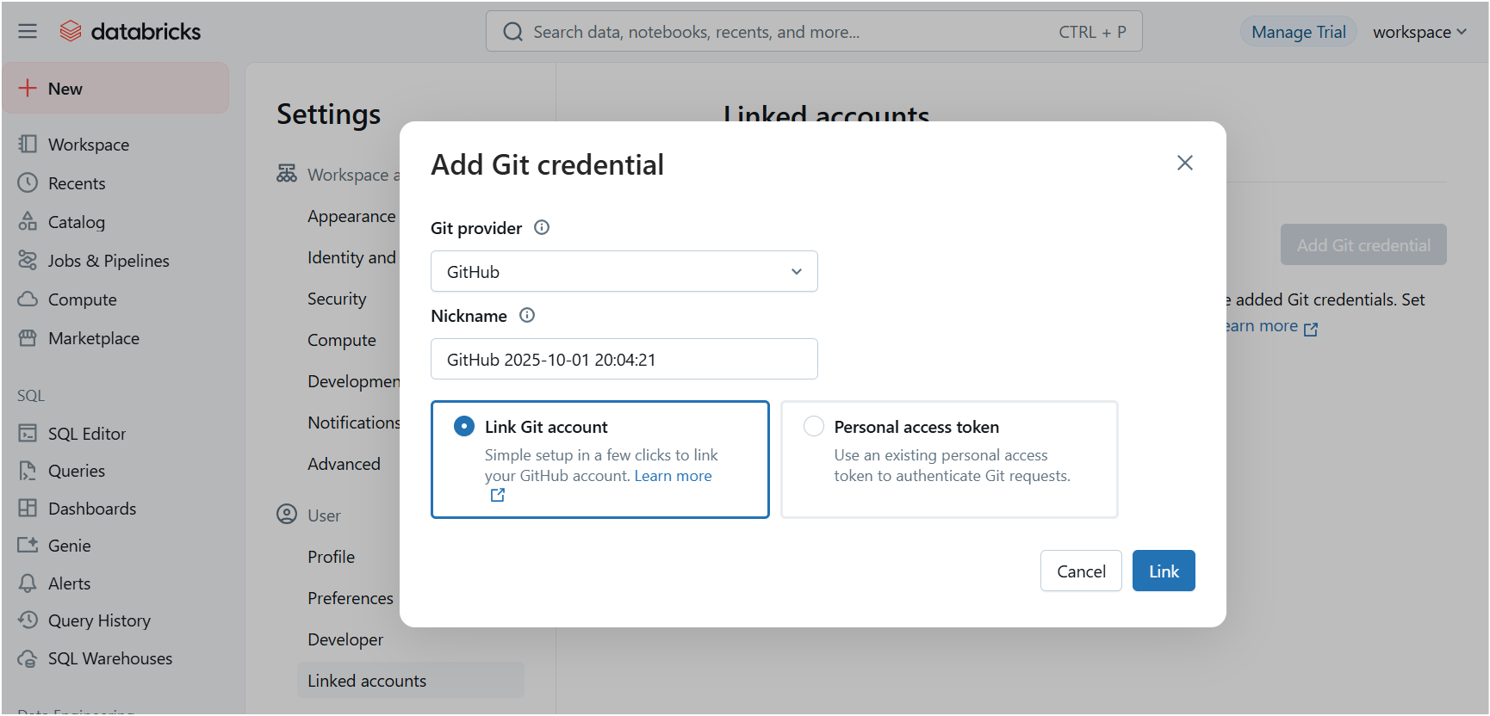

It has been linked now

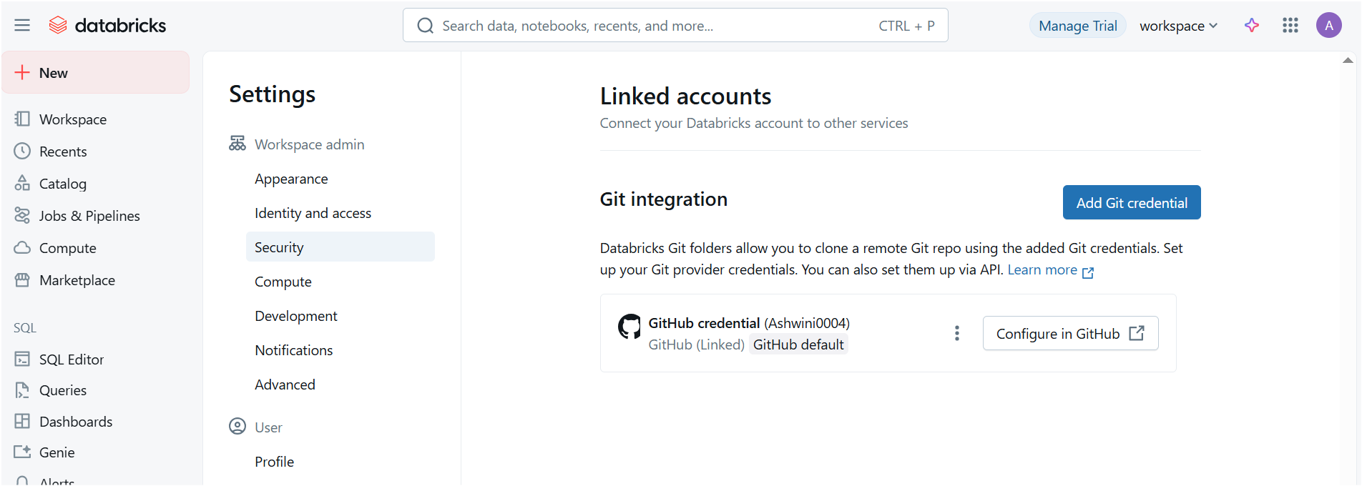

Step 8: Need to configure from git hub now.

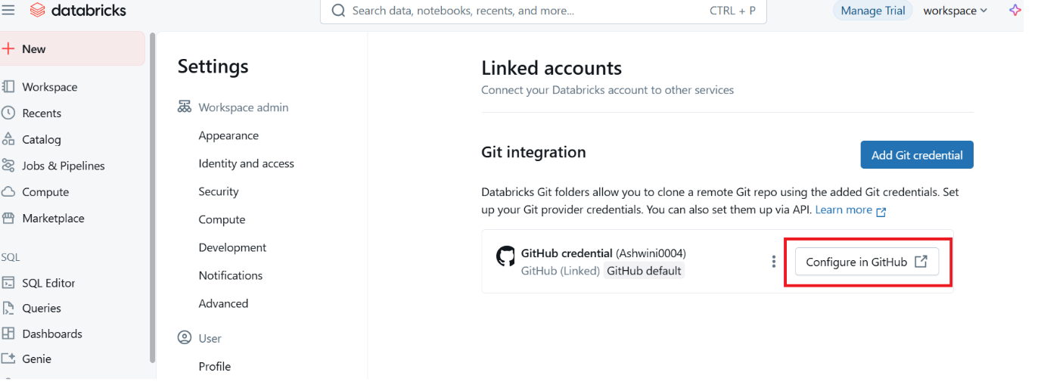

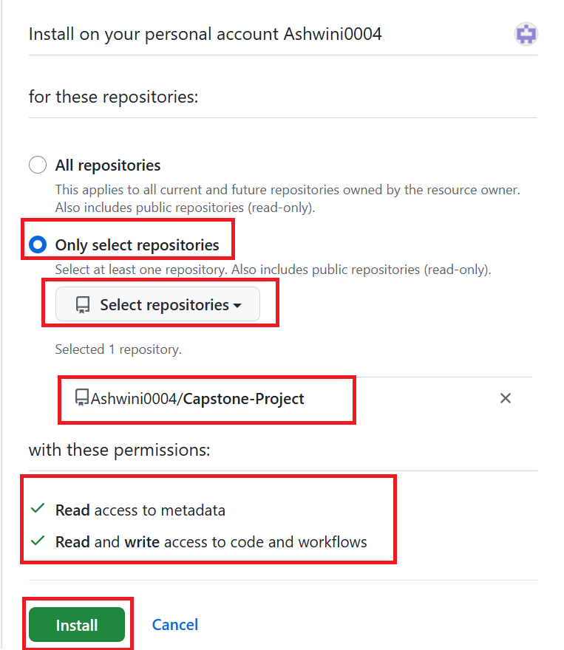

Step 9: Check git hub work

Goto databricks git folder main

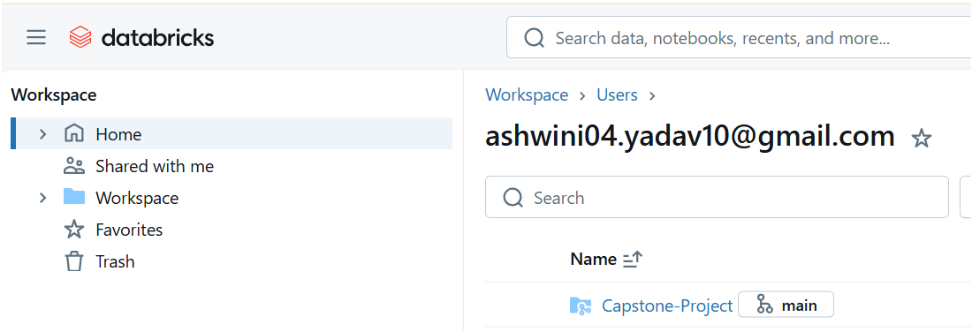

Commit this…

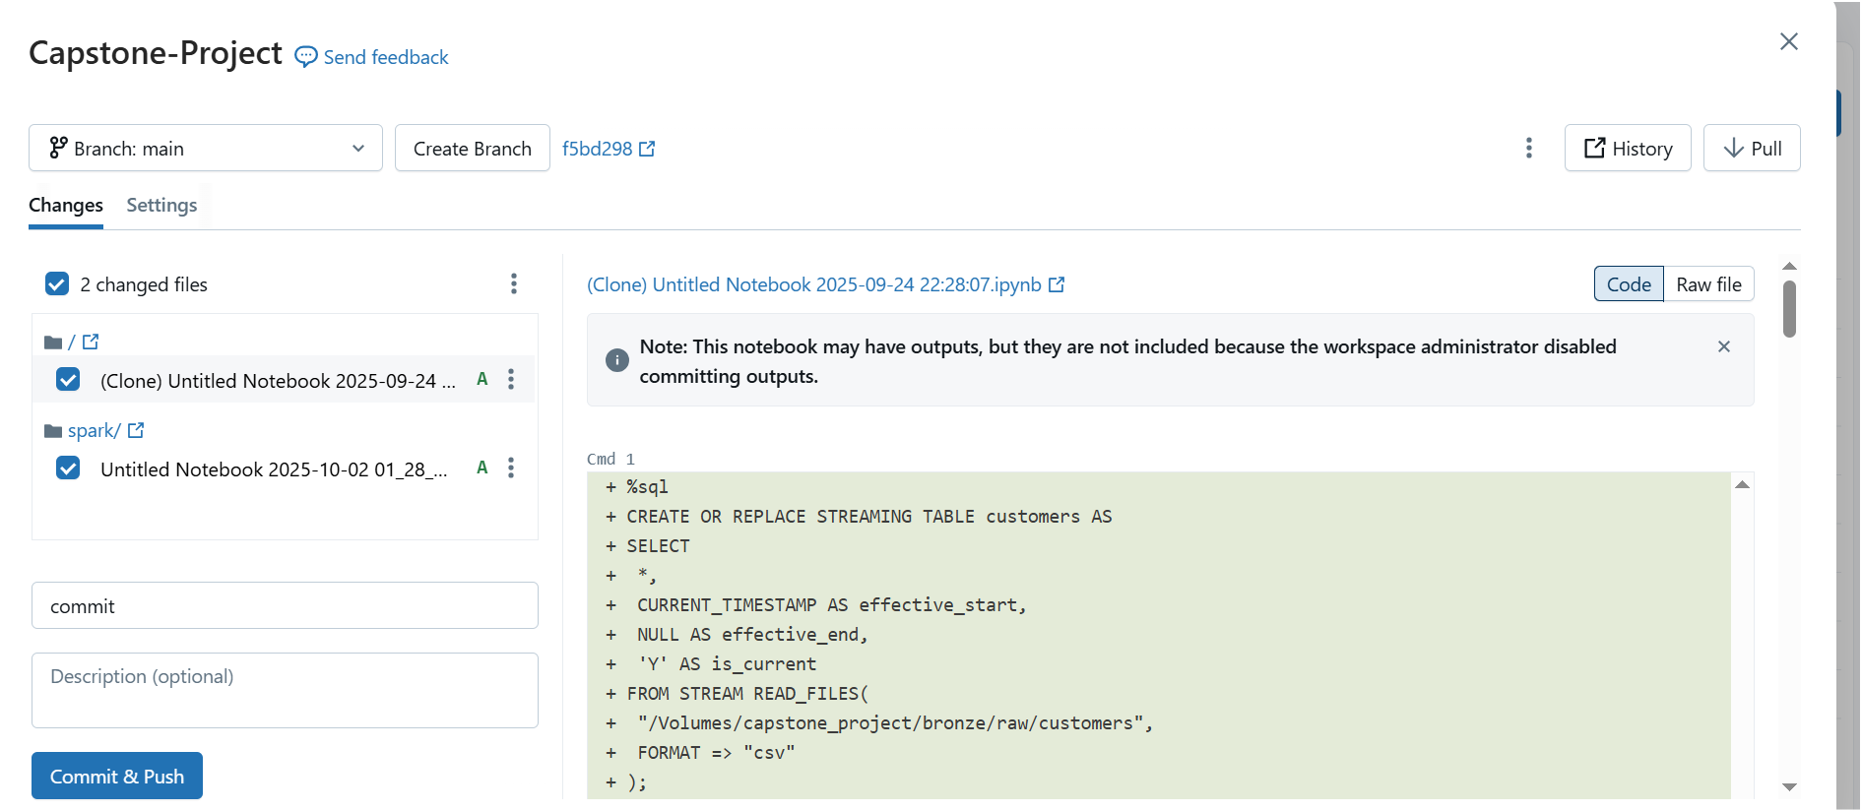

Successfully committed:

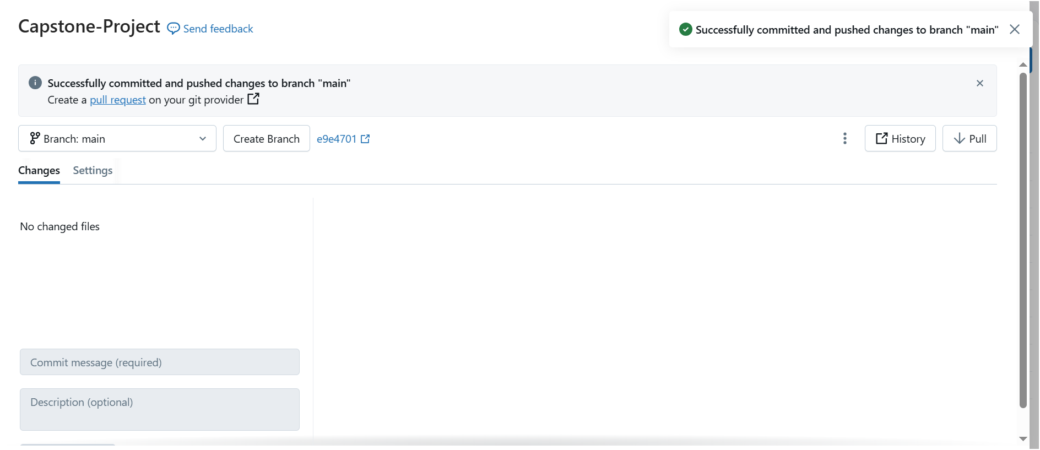

Step 10: Now check in to our git hub

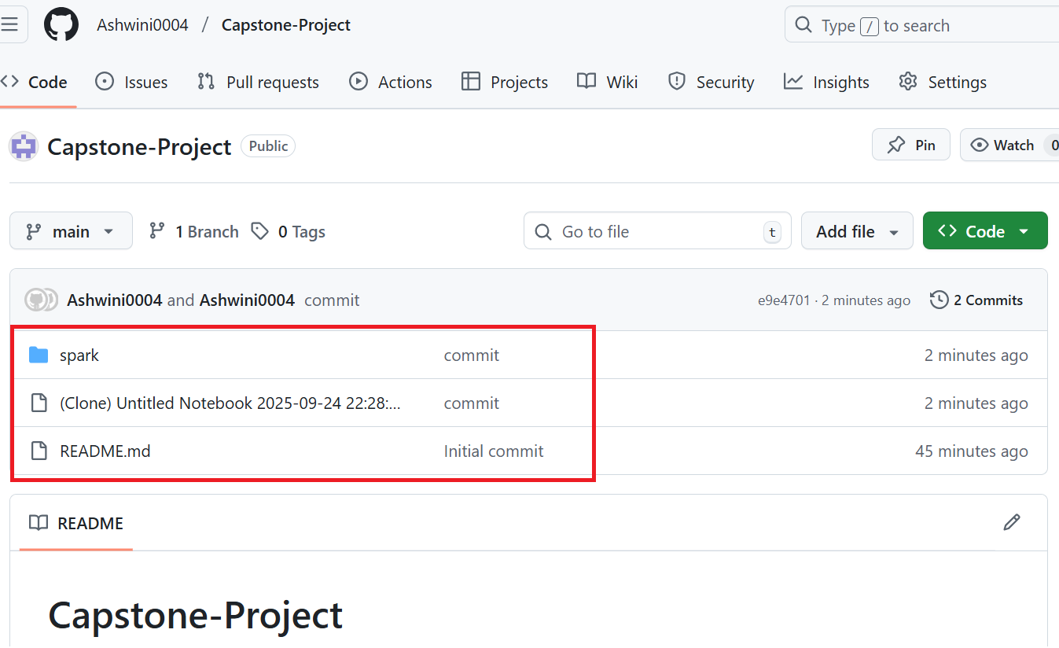

Step 11: Write new script into our databricks

Spark 🡪 notebook🡪 write new script 🡪 click on main

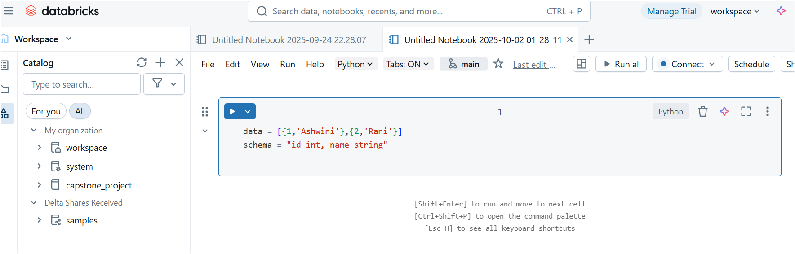

It will track a change. Commit it.

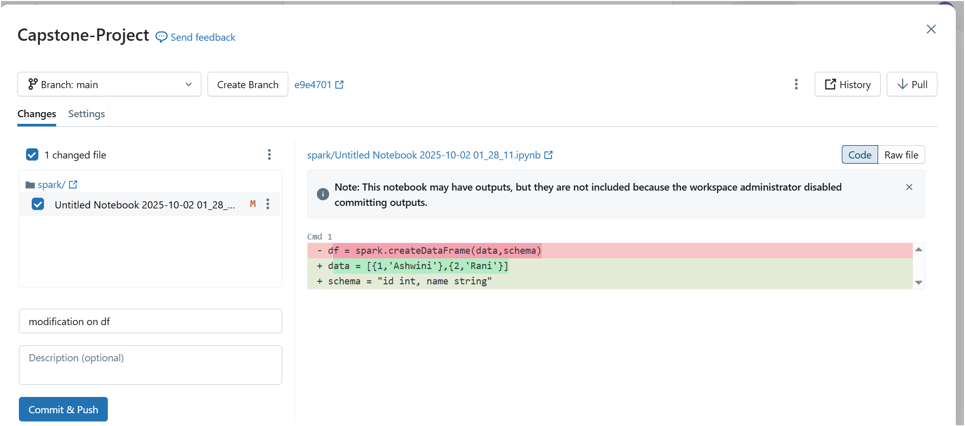

Changes will happen in git hub also

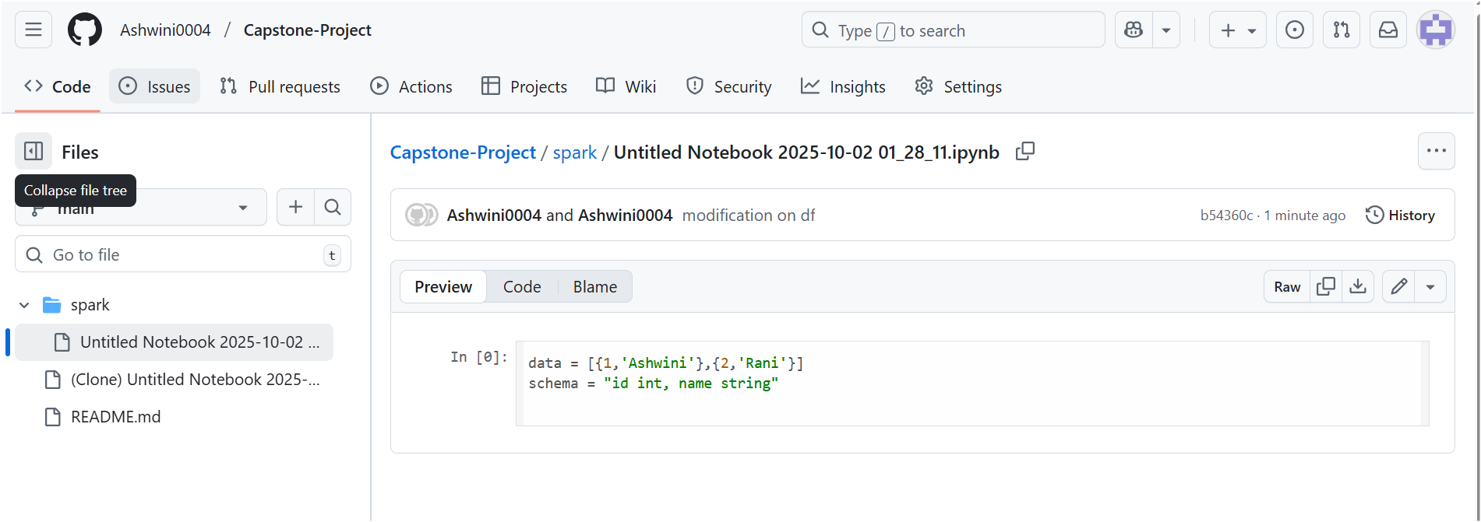

Now changes from git to databricks:

Goto github_dev

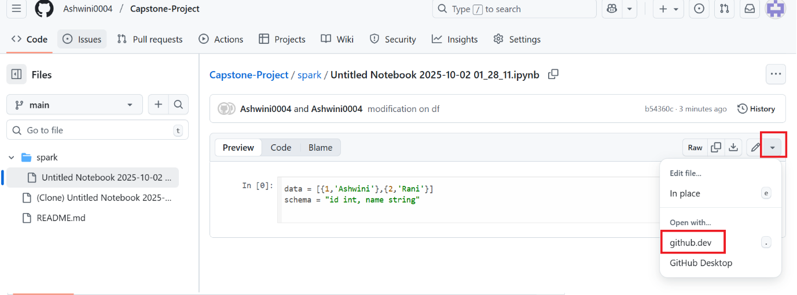

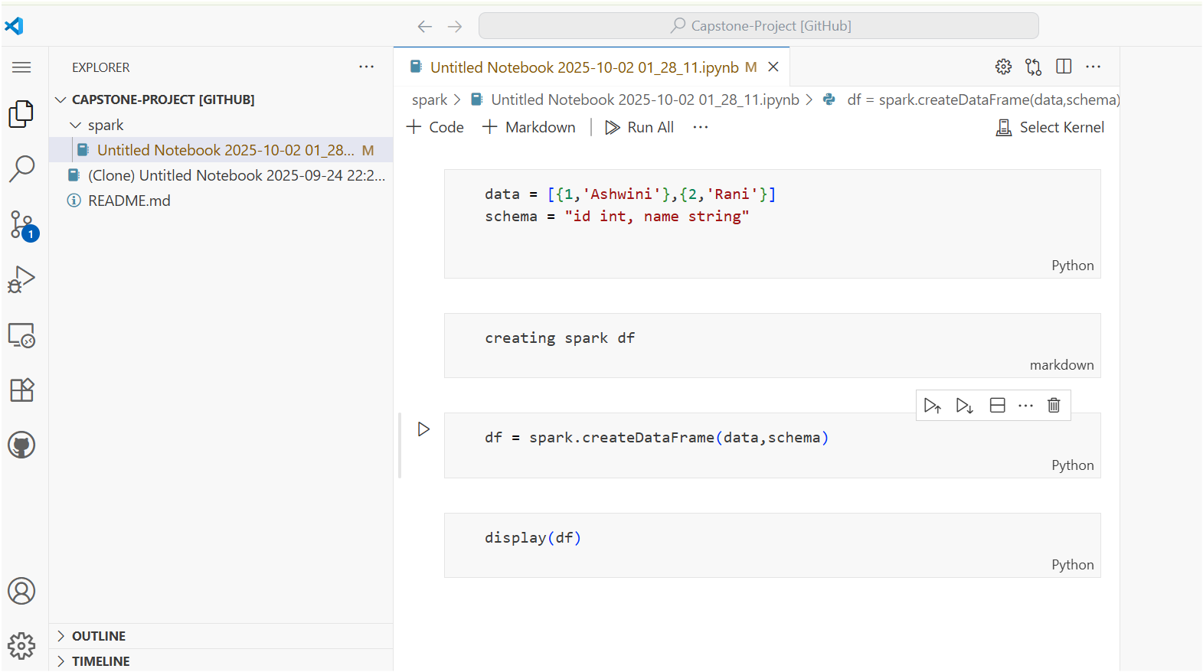

Commit & Puch it

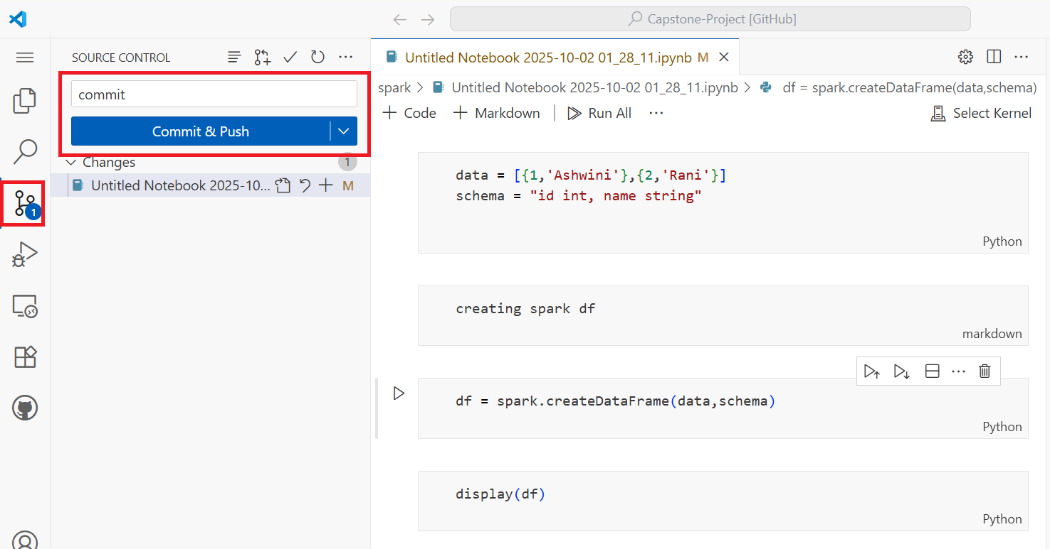

Now go back & see our text is present their.

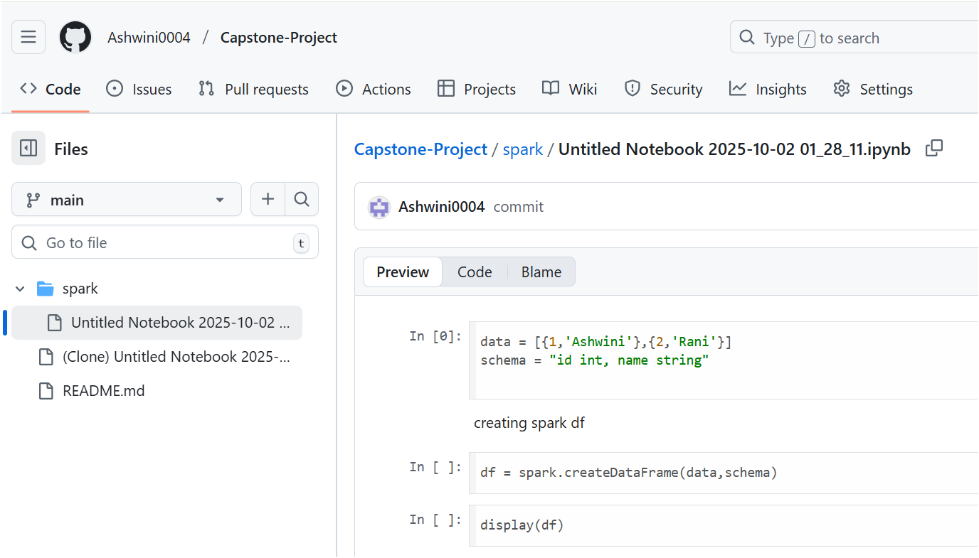

Now in the databricks if we refresh, nothing happened. We need to pull the code.

Goto 🡪 main on notebook 🡪 pull

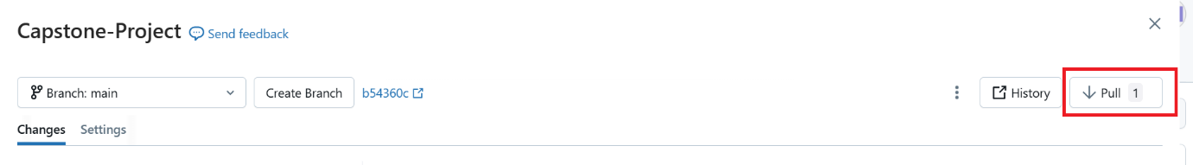

Message get successfully pulled.

Now goto databricks again n refresh it

All github changes are display here

